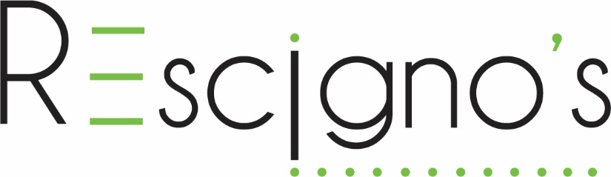

Job Description for Lead Consultant (Full-time Hybrid)
The Lead Consultant will provide strategic advice and counsel to non-profit clients regarding their Annual Fund and Major Gift programs. This position is the front-line person with our clients and the “face” of the company for the clients that Rescigno’s serves and supports. Not only will you be responsible for establishing and cultivating positive and profitable client relationships, but you will work with a team of project managers, designers, and data specialists ensuring the needs of your clients are met in all areas of project management. Your success will come from your willingness to understand your client’s business and mission, ability to effectively communicate in a diplomatic and tactful manner, as well as recognizing what is necessary and when, as you strive to help clients achieve their fundraising goals.
Objectives of this Role
- Help lead Rescigno’s in the planning and execution of strategies to increase consulting sales and overall company growth
- Identify needs and develop solutions for our clients’ Annual Fund and Major Gift strategies
- Provide Annual Fund and Major Gift strategies to Rescigno’s consulting clients

Functions/Expectations

Successful management is critical to producing quality deliverables on time and on budget for our clients. Managing workflow and meeting deadlines is part of the Lead Consultants role and responsibility. This position will:
- Work very closely with the project manager and team to create, plan and coordinate high-quality work.
- Proactively communicate progress, or lack thereof, against deadlines.
- All clients have different goals and needs and you will be expected to work independently on solutions and strategies.
- Work with the current staff to ensure top level client experience occurs in all client interactions from follow-up to delivery

Sales and Marketing

The Lead Consultant will support Rescigno’s business development and marketing activities, contributing to annual revenue and sales goals and authoring content in areas of expertise.
In this capacity the Lead Consultant will:
- Leverage networking opportunities to surface sales opportunities and work with team members to close business opportunities.
- Develop proposals, contracts and sales presentations.
- Work with sales leads and team to design and price services for clients.
- Represent Rescigno’s at industry/social events and conferences.
- Engage in some speaking/presentations on topics of expertise and create content marketing pieces like blogs and articles for newsletters.
- Work side by side with the Leadership Team towards increasing revenue generation and sales growth goals

Skills and Qualifications
- We are looking for individuals with previous experience in fundraising, development, marketing, or advancement. (CFRE preferred)
- Bachelor’s degree in related discipline (fundraising, business, direct marketing communications, graphic arts, print production management); minimum 3-5 years prior client-based experience in direct mail/marketing industry; or equivalent combination of education and experience.
- At least 5 years in a management role, with a proven history of fundraising success.
- Superior customer/client service skills with focus on tact, diplomacy and rapport building.
- Strong attention to detail with superior organizational skills.
- Strong people skills with the ability to work in a team environment and foster positive and collaborative work habits.
- Excellent project planning and problem-solving skills; ability to set milestones and administer action plan.
- Strong verbal and written communication skills; ability to communicate technical information to non-technical audiences – either staff or client.
- Ability to conduct client, supplier, and company relationships with high degree of integrity and professionalism in a supportive, respectful manner.
- Self-starter with experience within a fast paced, high-energy environment

We look for team members with a proven track record of creating happy, satisfied clients in a fast-paced, deadline-driven, project-oriented service-intensive environment. We are looking for individuals with a passion for creating a flawless service experience for customers.
Please contact Iris Zavala at Iris@Rescignos.com

