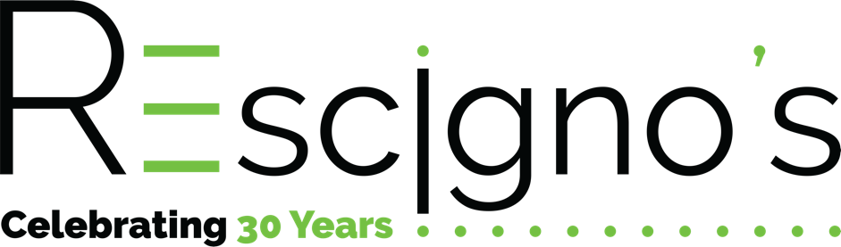
Job Description for Fundraising Copywriter/editor (Contract Work, Remote)
At Rescigno's, we attribute much of our success to the strength of our fundraising knowledge and expertise. To build on this terrific momentum, we're searching for a qualified copywriter/copyeditor to work closely with our team and clients. Your success will come from your willingness to understand our clients’ mission, and effectively communicate it through fundraising writing across a variety of platforms to help clients achieve their goals.
Objectives of this Role
- Write and edit print and digital fundraising and stewardship communications.
- Participate in strategy meetings to ensure clients’ vision and mission are clearly communicated in all writing projects.

Daily and Monthly Responsibilities
- Research, conduct interviews (when requested) and write fundraising appeal letters.
- Write email and social media copy to integrate appeal messaging across platforms.
- Write and edit impact postcards, impact reports, brochures, and annual reports.
- Collaborate on projects with colleagues in other departments, as needed.

Skills and Qualifications
- Rescigno’s works exclusively with nonprofits, so we are looking for individuals with previous experience in fundraising, development, or advancement writing.
- Bachelor’s degree in a related discipline (fundraising, writing, communications); minimum 3-5 years prior client-based fundraising writing and editing experience.
- Strong verbal and written communication skills
- Ability to meet deadlines and work with internal staff and clients within a fast-paced, high energy environment with a high degree of integrity and professionalism in a supportive, respectful manner.
- Understanding of project management and graphic design processes

We look for team members with a proven track record of creating happy, satisfied clients in a fast-paced, deadline-driven, project-oriented service-intensive environment. We are looking for individuals with a passion for creating a flawless service experience for customers.

To Apply

- Please send a brief introductory message of interest, resume, and writing samples to sue@rescignos.com

